 JS LED /SHENZHEN LIGHTING INC.
Call: BORDERLINE LED LIGHTING , 1-877-210-2200 or Cell: 208 305 3592

LED ROPE LIGHT ACCESSORY PRICE LIST
Effective Date: 02/11/2016
PART# | DESCRIPTION | Pictures | PRICE
RN101 | 110 AC input Power  Converter, drive 82 feet/pc | 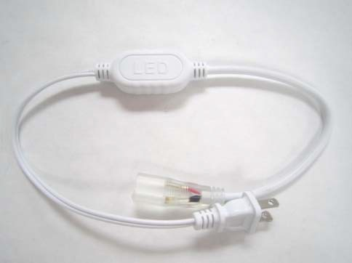 | $2.00
RN102 | Connection pin for single color rope light | 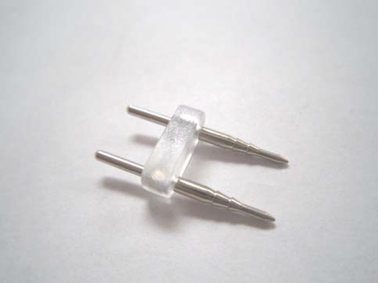 | $0.30
RN103 | Connection pin for RGB rope light | 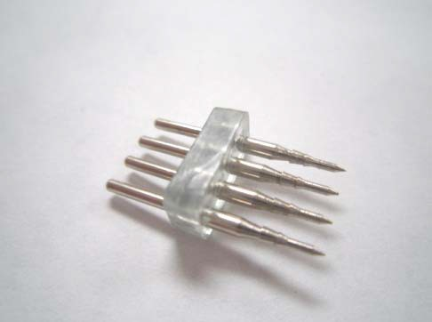 | $0.40
RN104 | Connector for single color rope light | 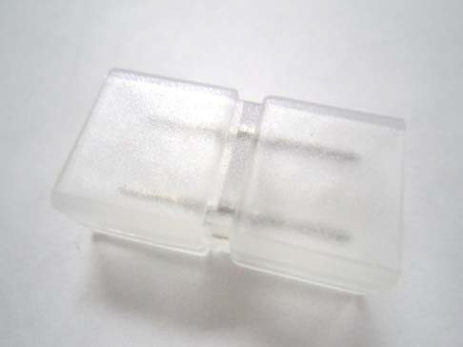 | $0.30

RN105 | Connector for RGB rope light | 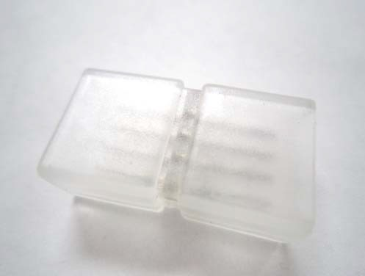 | $0.40
RN106 | 1 FT Extension Connector for single color rope light | 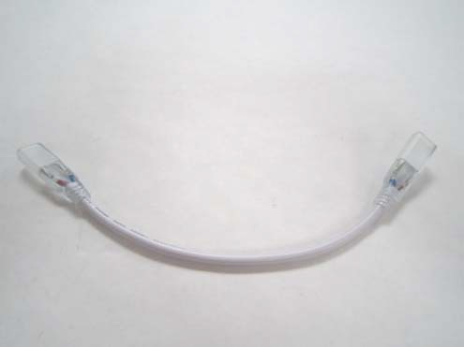 | $1.10
RN107 | End cap | 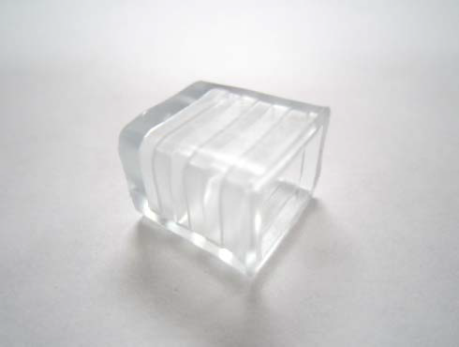 | $0.30
RN108 | RGB controller with 110 AC  input Power Converter | 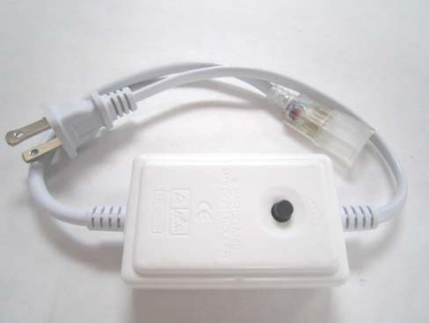 | $4.30
RN109 | RGB controller with remote  (110V AC input) | 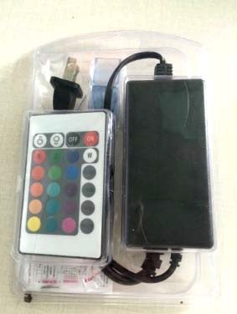 | $13.20
RN-110 | Clip | 